

Project Report

Project Title: Tic Tac Toe Game in C++

Group Members:
Name | Reg no.
Eiraj Faisal | 240901038
Roushaan Haider | 240901005
Hermain Kashif | 240901026

Submitted To:
Natiqa Gul
Object-oriented programming

Date of Submission:
13 June 2025

1. Introduction
This project simply implements the classic Tic Tac Toe game using C++. It allows two modes of gameplay:
- Player vs AI
- Player vs Player
The goal was to develop an interactive and functional game that demonstrates object-oriented programming concepts such as classes, inheritance, and eencapsulation.

2. Objectives
- To create a Tic Tac Toe game that can be played in two modes.
- To apply object-oriented programming principles.
- To practice working with 2D arrays, conditional logic, and user input.
- To introduce basic AI logic for automated opponent moves.

3. Features
- 3x3 grid board for standard Tic Tac Toe gameplay.
- Two game modes:
  - Player vs AI: Human plays against a basic AI that chooses from available empty cells.
  - Player vs Player: Two players take alternate turns.
- Input validation to prevent overwriting already filled cells.
- Clear display of the board after each move.
- Victory and draw detection.

4. Class Structure

Board Class
- Manages the 3x3 grid.
- Handles board display, cell updates, win checking, and empty cell detection.

AI Class
- Contains a simple strategy to select the next available cell for the computer.

Game Class
- Handles the flow of the game.
- Provides the player with a choice of mode (vs AI or Player).
- Manages turns, checks for a win or draw, and switches between players.

5. Screenshot of output:

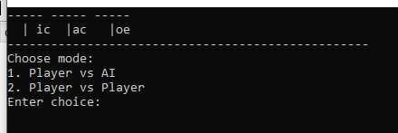
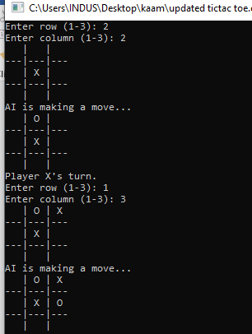
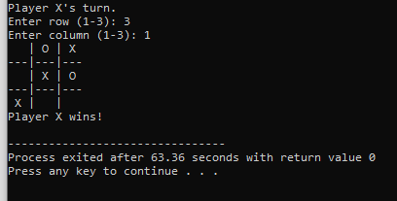

6. Conclusion
This project successfully implements a functional and interactive Tic Tac Toe game using object-oriented design. The addition of both AI and multiplayer options enhances the game's playability. It serves as a practical exercise in C++ programming and logical structuring of a game loop.

7. Future Improvements
- Add a smarter AI using the minimax algorithm.
- Allow players to choose symbols (X or O).
- Add a scoring system and replay option.

